**1.Area**

%macro print 2

mov rax,01

mov rdi,01

mov rsi,%1

mov rdx,%2

syscall

%endmacro

section .data

msg1 db 10,"Program to find area of circle:"

len1:equ $-msg1

msg2 db 10,"Area of circle is"

len2:equ $-msg2

dpoint db "."

hdec dq 100

r dd 3.0

section .bss

dispbuff resb 1

resbuff resb 10

area resw 4

section .text

global _start

_start:

print msg1,len1

finit

fld dword[r]

fmul dword[r]

fldpi

fmul

fst dword [area]

print msg2,len2

call disp_result

mov rax,60

mov rdi,0

syscall

disp_result:

fimul dword[hdec]

fbstp [resbuff]

xor rcx,rcx

mov rcx,09h

mov rsi,resbuff+9

up1:

push rcx

push rsi

mov bl,[rsi]

call disp8_proc

print dispbuff,02

pop rsi

dec rsi

pop rcx

loop up1

print dpoint,01

mov bl,[resbuff]

call disp8_proc

print dispbuff,02

ret

disp8_proc:

mov rdi,dispbuff

mov rcx,02

back:

rol bl,04

mov dl,bl

and dl,0Fh

cmp dl,09h

jbe skip

add dl,07h

skip:

add dl,30h

mov [rdi],dl

inc rdi

loop back

ret

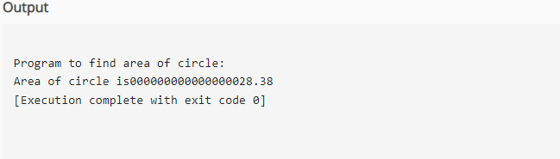

**2. Circumference**

%macro print 2

mov rax, 01

mov rdi, 01

mov rsi,%1

mov rdx,%2

syscall

%endmacro

section .data

msg1 db 10, "Program to find circumference of circle:"

len1:equ $-msg1

msg2 db 10, "Circumference of circle is"

len2: equ $-msg2

dpoint db "."

hdec dq 100

r dd 3.0

temp dd 2.0

segment .bss

dispbuff resb 1

resbuff resb 10

perimeter resw 4

section .text

global _start

_start:

print msg1,len1

finit

fld dword[r]

fmul dword[temp]

fldpi

fmul

fst dword[perimeter]

print msg2, len2

call disp_result

mov rax, 60

mov rdi, 0

syscall

disp_result:

fimul dword [hdec]

fbstp [resbuff]

xor rcx, rcx

mov rcx, 09h

mov rsi,resbuff+9

up1:

push rcx

push rsi

mov bl, [rsi]

print dispbuff,02

pop rsi

dec rsi

pop rcx

loop up1

print dispbuff,02

pop rsi

dec rsi

pop rcx

loop up1

print dpoint, 01

mov bl, [resbuff]

call disp8_proc

print dispbuff, 02

ret

disp8_proc:

mov rdi,dispbuff

mov rcx, 02

back:

rol bl,04

mov dl, bl

and dl,0Fh

cmp dl,09h

jbe skip

add dl,07h

skip:

add dl,30h

mov [rdi], dl

inc rdi

loop back

ret

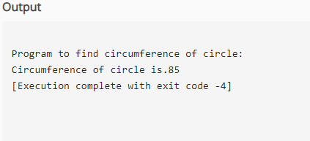  
**3.Mean**  
%macro print 2  
mov rax,01  
mov rdi,01  
mov rsi,%1  
mov rdx,%2  
syscall  
%endmacro  
section .data  
msg1 db 10,"Program to calculate mean:"  
len1:equ $-msg1  
msg2 db 10, "Mean is"  
len2:equ $-msg2  
dpoint db "."  
hdec dq 100  
num1 dd 102.59  
num2 dd 198.21  
num3 dd 100.67  
num4 dd 3.00  
section .bss  
dispbuff resb 1  
resbuff resb 10  
mean resd 1  
section .text  
global _start  
_start:  
print msg1, len1  
finit  
fld dword [num1] ;102.59  
fld dword [num2] ;198.21  
fadd st0, st1 ; ;300.8 ;top of stack  
fld dword [num3]; 100.67 is loaded on to the stack  
fadd st0, st1 ;100.67+300.8-401.47<-ST(0)  
fdiv dword [num4] ;st0=add/3-mean=334.35667  
fst dword[mean]  
print msg2,len2  
call disp_result  
mov rax, 60  
mov rdi, 0  
syscall

disp_result:  
fimul dword[hdec]  
fbstp [resbuff]  
xor rcx, rcx  
mov rcx, 09h  
mov rsi,resbuff+9  
up1:  
push rcx  
push rsi  
mov bl, [rsi]  
call disp8_proc  
print dispbuff, 02  
pop rsi  
dec rsi  
pop rcx  
loop up1  
print dpoint, 01  
pop rsi  
dec rsi  
pop rcx  
loop up1  
print dpoint, 01  
mov bl, [resbuff]  
call disp8_proc  
print dispbuff,02  
ret  
disp8_proc:  
mov rdi, dispbuff  
mov rcx, 02

back:  
rol bl,04  
mov dl,bl  
and dl,0Fh  
cmp dl, 09h  
jbe skip  
add dl,07h

skip:  
add dl,30h  
mov [rdi], dl  
inc rdi  
loop back  
ret

